Project Execution Steps
1. Copy the given project folder in your system.
2. Right click on the folder, select the properties and click on web sharing tab
3. Click on share this folder in the following screen
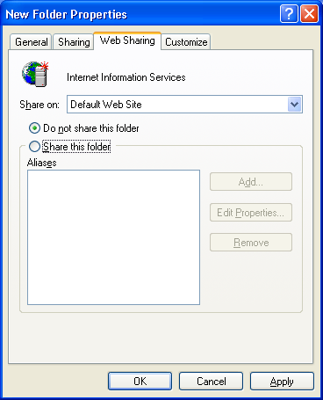

4. Select Write, Script source access and Directory browsing
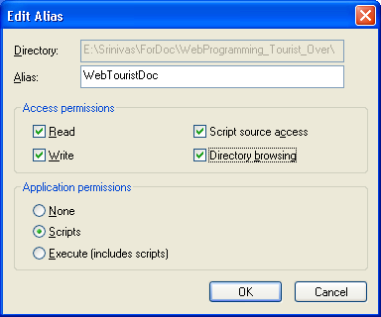
5. Click on ok and then Apply
6. Open web.config file from project folder and change ConnectionString parameters like
- Database/Initial catalog
- U id/User id
- Pwd/Password
- Data source/Server
8. Then save the web.config file

